Move Until Color Unit Level Quiz
- What is a threshold?
- Your Color sensor is reading a value of 16 in an environment where 8 was considered dark and 26 was considered light. Will your robot recognize the present reading of 16 as light or dark? Why?
- The program below has a tribot move on the floor and stop on a line. Is the floor dark or light? If the line registers as 60 on the light sensor, what is the reading over the floor?
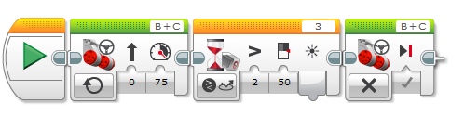
- Ziffle writes a tribot program that will wait for the lights in the room to be turned off, then say “Goodbye!” and drive backward into its corner of the room for 15 seconds. Upon trying the program, Ziffle is disappointed to learn that the tribot’s parting words are hard to hear. What two changes to the Sound block could Ziffle make that would allow the tribot to be better heard?
